Lead Me Home
Project Proposal 2023

Project Name: Lead Me Home

Background: As Sri Lanka struggles to recover from an economic crisis, the poverty gap grows and the poor become poorer. Zooming into Polgahawela, there is a single mother with three children, working at a garment factory to make ends meet. When it rains, the four of them huddle together in a small space covered with tin (takaran) sheets, hoping that the water won’t leak more than it did the day before, and hoping that no snakes would slither in from the ground. Yet, with smiles on their faces, they persevere. And so can we, in trying to provide them with a better form of shelter by constructing two rooms, a kitchen and a washroom for this family.

Project Objectives:
- To provide sufficient sleeping quarters without extreme external disturbances;
- To create space for the children to study more efficiently for upcoming exams;
- To ensure that they have clean washroom facilities.

Project Duration:
Frequency
One-off
Short Period (1 – 3 day)
Extended Period (more than 3 months) | X

Project's Initial Itinerary (Important Dates):
- 6th March 2023 – Field Visit
- 18th March 2023 – Start social media advertising
- 3rd week of March 2023 – Create the funding link
- 4th week of March 2023:
- Create bank account
- Reach out to the media
- Reach out to potential partners/ sponsors
- Reach out to raw material distributors
- 1st week of April 2023 – Level the site ground

Project Plan:

We will be constructing a bedroom, a study room, the kitchen and the washroom as indicated in the plan below:

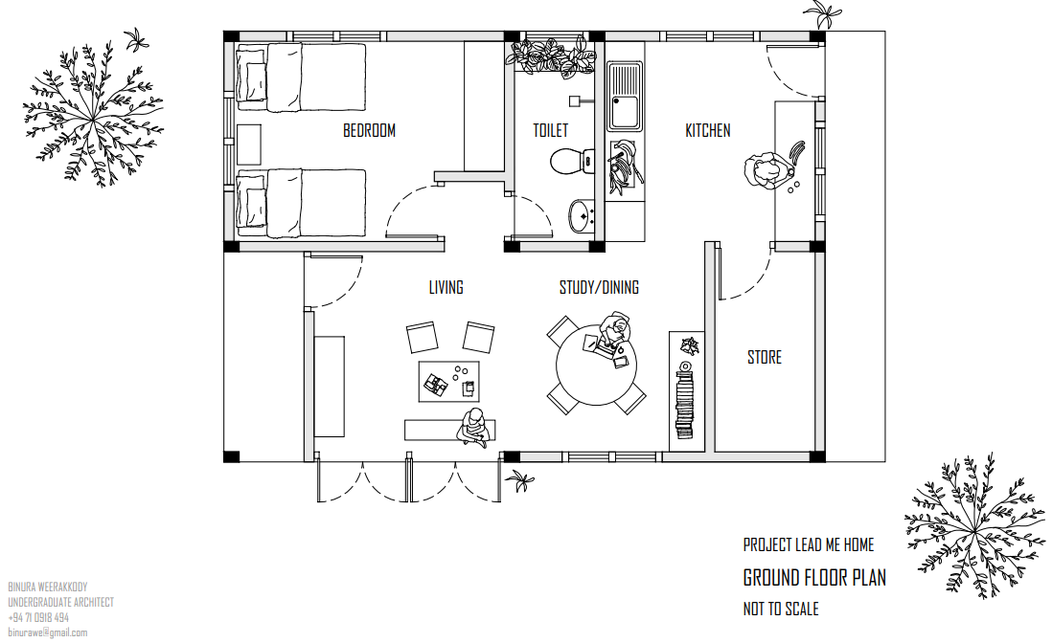

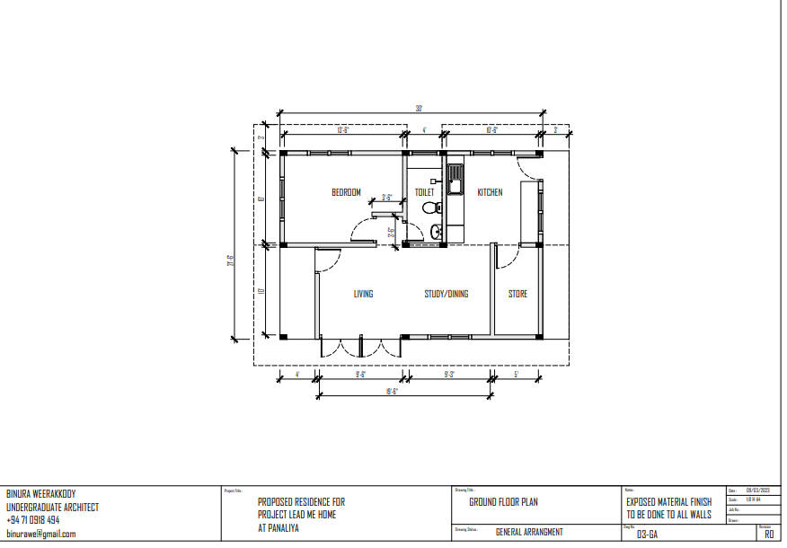

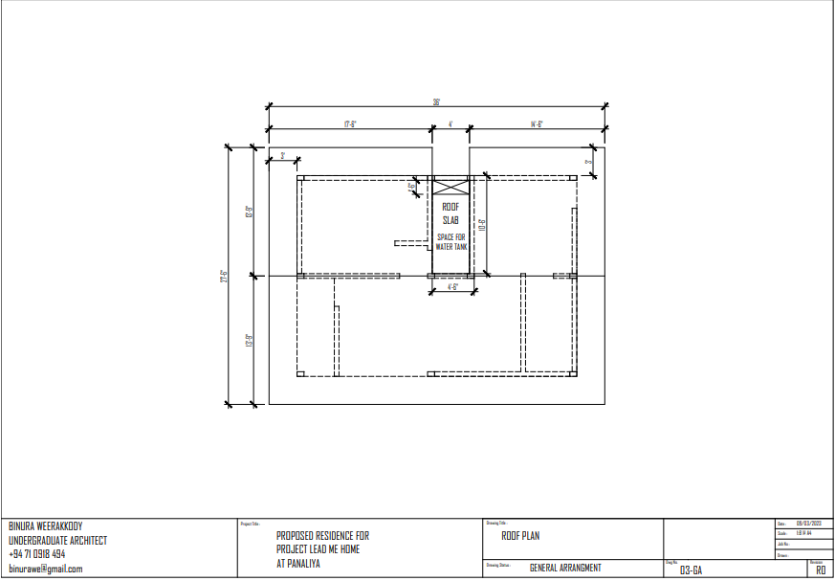

Project Budget:
Budget A
IDEAL BUDGET
Trades | Amount (LKR)
EXCAVATION AND EARTH WORK | 115,500.00
CONCRETE WORK | 796,550.00
MASONRY WORK | 999,000.00
ASPHALT WORK (WATER PROOFING ) | 26,750.00
CARPENTRY, JOINERY AND GLAZING WORK | 366,937.50
ROOFER & ROOF PLUMBING | 503,700.00
FLOOR , WALL AND CEILING FINISHES | 516,250.00
PAINTING WORK | 225,000.00
PLUMBING & INTERNAL DRAINAGE | 208,665.00
DRAINAGE AND STORM WATER DISPOSAL SYSTEM | 137,000.00
ELECTRICAL INSTALLATION | 238,200.00
TOTAL AMOUNT | 4,133,552.50

Budget B
LOW COST BUDGET
Trades | Amount (LKR)
EXCAVATION AND EARTH WORK | 105,000.00
CONCRETE WORK | 600,000.00
MASONRY WORK | 650,000.00
ASPHALT WORK (WATER PROOFING ) | 26,750.00
CARPENTRY, JOINERY AND GLAZING WORK | 250,000.00
ROOFER & ROOF PLUMBING | 300,000.00
FLOOR , WALL AND CEILING FINISHES | 220,000.00
PAINTING WORK | 75,000.00
PLUMBING & INTERNAL DRAINAGE | 150,000.00
DRAINAGE AND STORM WATER DISPOSAL SYSTEM | 50,000.00
ELECTRICAL INSTALLATION | 100,000.00
TOTAL AMOUNT | 2,506,750.00

As part of our project proposal, we have developed two distinct budgets to help us better plan and manage our resources. The first budget, Budget A, represents our ideal financial plan, one in which all of our desired resources are available to us. However, given that this is our first project, we recognize the need to be more practical and cost-conscious in our planning. Therefore, we created a second, more realistic budget, Budget B. This budget was developed after carefully estimating possible avenues for cost reduction, while still ensuring that we can raise the necessary minimum to successfully execute the project. Ultimately, our goal is to strike a balance between our ideal vision and the realities of the resources available to us.

Project Details:
The team has conducted a field visit on the 6th of March 2023 with the purpose of:
- Filming and collecting sufficient content for media promotion for all social media platforms
- Meeting with the family and getting to converse with them about the problems that they are facing
- Canvassing the area to find a suitable location to build the new house
- Ensuring that the wildlife and nature in that area are not destroyed/ruined with the building of this project
Whilst we were there, we noticed that there are areas with less electrical wiring. We have taken that into account when creating the budget. In addition to the electrical issues, we also took note of the lack of water supply in the area and have allocated resources to building a well.

The field visit also allowed us to work with the architect to ensure that the architect could observe the area and make his plans accordingly.

In terms of media promotion, we will be reaching out to well-known influencers and asking them to post about the project to get the word out. Additionally, we will continue to boost our posts to reach a wider audience. We have also looked into using a Tribe Funds link for donations allowing us to be advertised on their platforms as well.

In terms of obtaining funds, we are working on looking for sponsorships and partnered fundraising. We would like all interested parties to note that our bank details are as follows:
Bank name  Commercial Bank of Ceylon Plc.  Maharagama Minicom Branch | Account Number  8209002561
Account Name  G.J.S. Kuruwita  Thinula Vidmal Karunarathne | SWIFT Code  CC E YL K LX

Project Members:

Member Name | Member Role | Member Email
Hithara Kuruwita | Project Leader | hitharahhk@outlook.com
Hasna Rizwan | Public Relations | hasnaaaliyah@gmail.com
Malaak Hashim | Public Relations | malaak.aishath@gmail.com
Saathvikaa Venget Gnani | Resource Management | saathvikaagnani2301@gmail.com
Thinula Karunarathne | Treasurer | thinula2123@gmail.com
Binura Weerakody | Architect | binurawe@gmail.com
Galagama Mudalige Upul Shantha | Quantity Surveyor | gmupul@gmail.com
Thugha Ahmed | Secretary | thugha.aa@gmail.com
Ranul Perera | Resource Management | ranulperera007@gmail.com
Mudalige Hiruni Perera | Resource Management | pererahiruni17@gmail.com

- The PR team is responsible for preparing the press kit and advertising the project on all social media accounts in hopes of obtaining sufficient funds;
- The RM team is responsible for contacting the media, potential sponsors, potential partner organisations, and distributors.
- The treasurer is responsible for creating the bank account and donations link, while maintaining a record of all the financial transactions to be transparent to all our donors, sponsors and partners.

Prepared by,  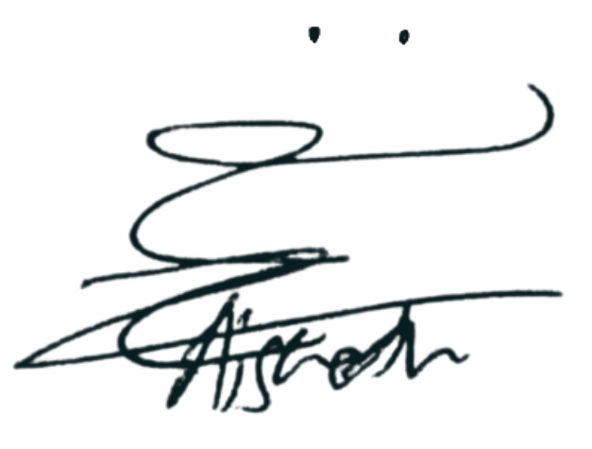  Thugha Ahmed  Secretary  Project Lead Me Home  Necessitize (Organization) | Checked by,  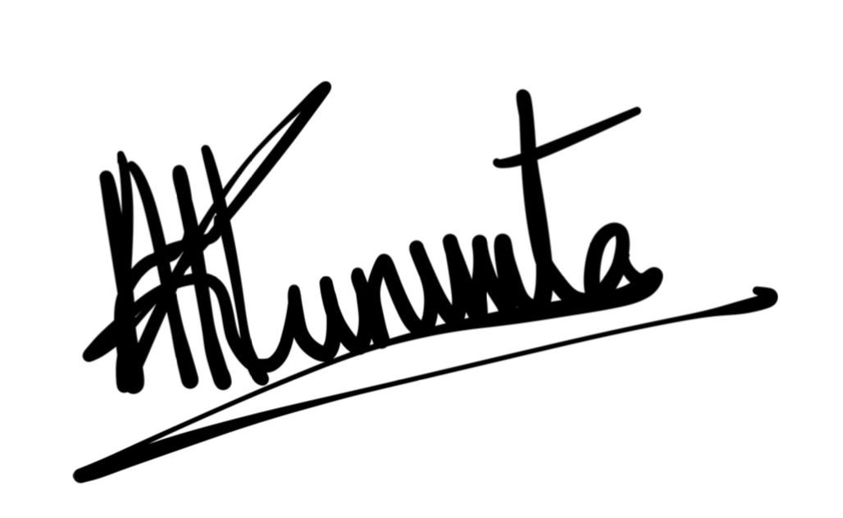  Hithara Kuruwita  Project Leader  Project Lead Me Home  Necessitize (Organization)

